Suncokret Project Summary
Short description of the project

Suncokret - Centre for Community Development is a Croatian non-governmental, non-profit organization founded in 2004 as a response to the psychosocial needs of a rural community. Suncokret runs a Community Center and a Local Volunteer centre project strength in rural Croatia, where we empower socially excluded children, youth, and the elderly in an isolated, impoverished, and ethnically divided post-war and post-earthquake region. Through our programs, we provide innovative, inclusive, and enriching activities for more than 200 local residents, enhancing their resilience, well-being, and quality of life. Each initiative is designed to meet real community needs and address local challenges.
This rural area of Croatia was deeply affected by the 1990s war, leaving behind lasting ethnic divisions and economic hardship. Further devastation came with the 2020 earthquakes during the COVID-19 lockdown, worsening social and economic instability. The region now faces depopulation, loss of social cohesion, and limited opportunities for youth, who often leave in search of better prospects—though many express a desire to return. Our community urgently needs renewed solidarity, inclusion, and sustainable opportunities to rebuild a stronger, more connected future.
For over 22 years, Suncokret has been promoting social inclusion, lifelong learning, and community resilience through free non-formal education and creative opportunities otherwise unavailable in the area.
Our activities include:
- International volunteer camps and long-term volunteer placements
- Non-formal educational programs for children and youth
- Intergenerational activities promoting understanding and cooperation
- Sustainability workshops in eco-gardening, permaculture, and biodiversity
Together, these efforts empower individuals, revitalize the community, and foster hope and connection in a region striving to recover and thrive.

Short description about hosting city/village
Vrginmost is a small rural town in a post-war region of continental Croatia, known for its welcoming community and peaceful surroundings. The town offers basic amenities, including one restaurant, several cafés, a supermarket, a local marketplace, and several small shops. The day care and elementary school serves about 100 children from Vrginmost and nearby villages. There are football and basketball courts, playgrounds and park, a river, and the Suncokret Community Centre and Local Volunteer Centre, which plays a vital role in local life.
Nestled among hills, forests, and rivers, Vrginmost is surrounded by beautiful nature, ideal for hiking, cycling, and walking. The area also features forest trails and a small lake for swimming during summer. While located in Croatia’s continental heartland, it remains a great base for exploring the country’s diverse regions and culture.

Expected tasks of the volunteer:
Suncokret works to provide educational and recreational activities in areas where such opportunities are otherwise limited. Our mission also focuses on promoting social inclusion for marginalized returnees, refugees, and internally displaced persons. Through our programs, we engage local children and youth with fewer opportunities, emphasizing inclusion, personal growth, and community development.
Our volunteer program encourages informal and non-formal learning, mobility, and intercultural dialogue. Volunteers and local youth have the opportunity to learn from each other, broaden their perspectives, and develop new competencies and skills.
Volunteers will work daily with socially excluded rural children and youth, sharing cultures, experiences, and knowledge through creative, non-formal, and informal educational methods. Additionally, Suncokret hosts several international volunteer camps each summer, offering ESC volunteers the chance to participate, collaborate, and connect with young people from around the world.
During the project, volunteers will be involved in the following activities:
- Daily educational and non-formal learning workshops, such as:
  - Language learning
  - Photo and video editing, journalism, newsletter creation, social media
  - Arts and crafts
  - Non formal learning and homework help
  - Sports activities
  - Sustainability, eco-construction, and eco-gardening
  - Recreational games and creative play
- Local community actions supporting social inclusion and development.
- Office and organizational support tasks, giving volunteers the chance to learn how a community development NGO operates.
- Independent initiatives and personal projects, developed with the guidance and support of Suncokret staff.
- Promotion of the ESC program, solidarity, and volunteerism. Volunteers will present ESC opportunities and share their personal motivations for volunteering. They will also introduce their home countries, cultures, and traditions to the local community.
- Community outreach and collaboration, including visits to local schools, day-care centers, and activities supporting individuals affected by the December 2020 earthquakes. Volunteers may also collaborate with partner organizations in Glina (e.g., in the day-care center or library), providing non-formal learning activities, assisting the elderly, and organizing programs for children and youth impacted by the earthquakes.

Working hours and days off:
The volunteer will work 35 hours a week maximum, five days of the week and has 2 days off each week. The volunteer will have 2 days extra holidays per volunteer month, in addition to national holidays. Holidays will be taken in agreement with the host organization.

Finances, Food and Accommodation
The volunteer will receive an allowance and a monthly food allowance, paid directly by the hosting organization. Volunteers are responsible for managing their food budget, purchasing groceries, and preparing their own meals.
As with other volunteer projects, there is a reimbursement of travel expenses up to a maximum limit set by the European Commission. Food, accommodation, language courses, training, tutoring, monthly pocket money and insurance are covered by the program.
Accommodation Details
- Type: Private room in a shared flat, and three dorms with shared rooms
- Bathroom: Shared with one other person
- Kitchen: Shared with one other person
- Facilities: The accommodation includes a washing machine; Wi-Fi is available at the community center/workplace
- Description: The small shared house consists of two bedrooms, a kitchenette, and a bathroom. Next door, there is a larger volunteer house with a spacious kitchen, living room, and additional shared amenities.
The accommodation is within walking distance of the community center. It is a shared living environment, where volunteers typically share rooms, bathrooms, kitchens, and common spaces with others. During volunteer camps or special activities, there may be temporary periods of shared accommodation with larger groups.
Volunteers are expected to maintain cleanliness and order in the house, cooperating with others in daily chores.
Policies and House Rules
Suncokret maintains a zero-tolerance policy on drugs and has specific rules regarding alcohol and smoking, which all volunteers must agree to before arrival.
Upon arrival, volunteers will be introduced to:
- Suncokret’s orientation and introduction to the project
- Activity work schedule
- Working rules and procedures
- House and accommodation guidelines
- Shared responsibility and cleaning routines

Local Transport
In general, there is no need for local transport because the accommodations, office and work locations are all within walking distance. The volunteer may come to work by foot or by bike. If we volunteer in other locations (Eg. Glina and Topusko) we travel with the Suncokret car and there is no cost to the volunteer.

Do you have any deadlines for applying? There is no deadline. In this case, apply as soon as possible as we have immediate availability.
More information about the project
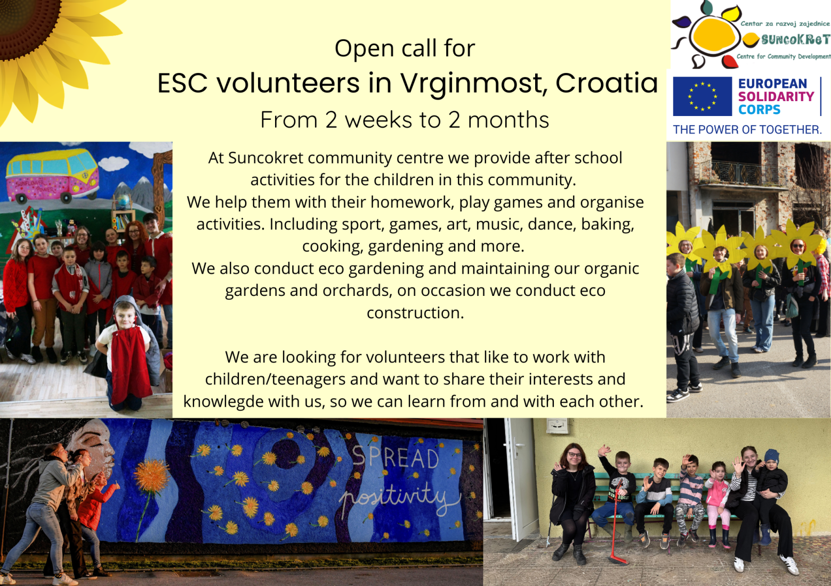
At Suncokret Community Center, we create a vibrant space where children can learn, grow, and have fun after school. We offer support with their homework, but that's just the beginning! We play games, organize exciting activities, and encourage creativity in all forms—whether through sports, art, music, dance, baking, cooking, or gardening. There's always something new to explore!

But our mission goes beyond just fun and games. We care deeply about the environment, which is why we run eco-gardening projects, nurture our organic gardens and orchards, and sometimes even dive into eco-construction. It’s about making a positive impact on both the kids and the world around us.

We’re looking for passionate, open-hearted volunteers who love working with children and are eager to share their skills and ideas. If you want to make a real difference, learn from others, and be part of a community that’s all about growth—then come join us! Together, we can create a space where everyone thrives.
You can apply here: https://forms.gle/qVkfY7q1MjDZNFBY8
For more information about our projects and activities: www.suncokret-gvozd.hr
Facebook: @suncokretccd Instagram: @suncokret.gvozd

