INFO PACK

1 volunteer
Point Information Jeunesse de Vallons de Haute Bretagne Communauté
9 months : November 2020- Aout 2021
Guichen (20km south Rennes)
Topics : Youth Information Center
International mobility workshop
Creation of youth events

What is a Youth Information Service

The PIJ (Point Information Jeunesse) is a youth service that provides free, confidential, reliable and accurate information to young people. It tries to answer certain questions that a youngsteer may ask themself in different fields :
- careers guidance
- studies and scholarships
- jobs and training
- general health matters
- relationships and sexuality
- rights of young people
- International mobility
Furthermore, the PIJ works with the local youth in order to propose several events all year long : concerts, summer jobs forum, festivals, conferences, workshops…

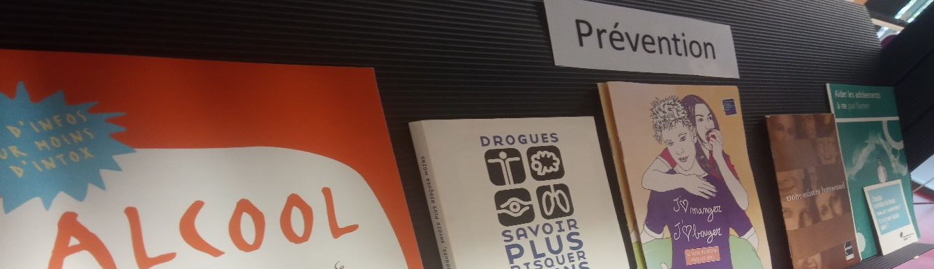

Vallons de Haute Bretagne Communauté

Vallons de Haute Bretagne Communauté (VHBC) is a community of municipalities which aims to associate the member municipalities within a space of solidarity with a view to developing a common project. It is located in Brittanny, in the department of “Ille-et-Vilaine” towards the south of Brittany’s capital city –Rennes-
In this territory, there are three villages that have a Youth Information Center: Guichen, Maure de Bretagne and Guipry-Messac.

Bretagne
Vallons de Haute Bretagne Communauté
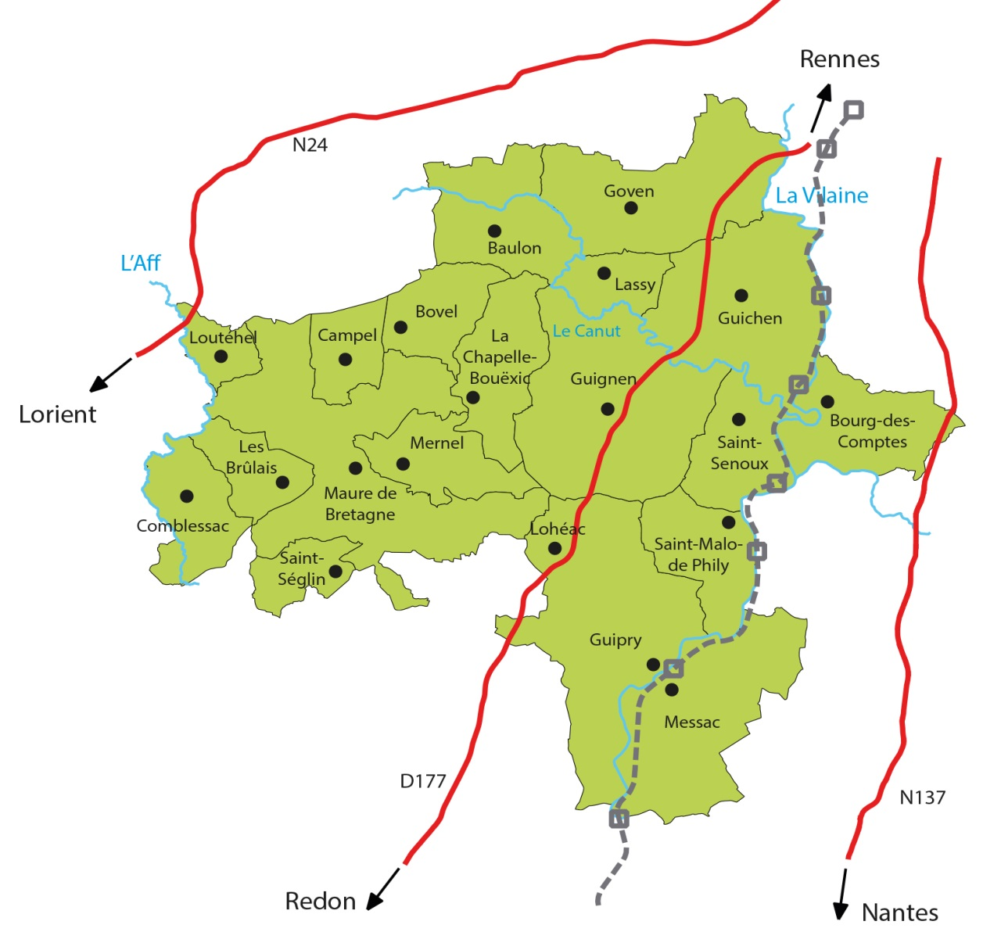
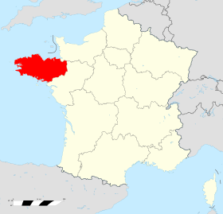
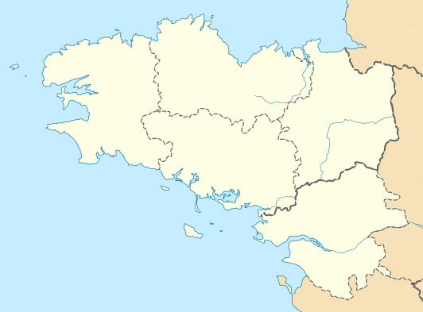
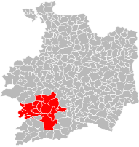

There are two professionals of the youth information that anime theese three PIJs. The volunteer will work in this three PIJs in a collaborative work with the two Youth Informators.
Reunan Eladio 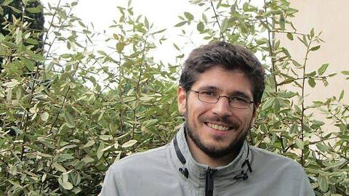 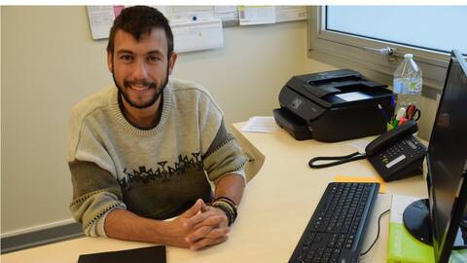

Project description
The volunteer will be integrated into the various missions of the Youth Information Center.
Host the local youngsters in the Youth Information Center, accompany the Informators in their daily tasks, participating in local working meetings, implementing locals youth events, etc.
Above all the mission, the volunteer will develope activites related to international mobility :
- Facilitating information workshops on international mobility: how to prepare for a departure abroad, presentation of the European Union’s mechanisms, discovery of Europe and its country, advantages of leaving, give envy. In the Youth Information Centre there are all the tools and resources to talk about mobility abroad.
- Support the promotion and restitution of youngster who have lived international experiences : photo expositions, creation of videos, conferences, language tamdem…
- Personal project: The volunteer will be able to propose and implement other projects according to the opportunities, context and skills. As part of a personal project, he will have the opportunity to set up a project in connection with the international.

Training during the project
The volunteer will take part in an on-arrival training and mi-term evaluation organised by the National Agency. The Youth Information Center will give them all the means to acces to the loca leisure activities for young people of Gucihen and Rennes.

Volunteer profile
No specific qualification or language level is required. The future volunteer should have a taste for animation and communication with young people. If the volunteer has skills with information and communication technologies (social network, image and sound), this will be a plus, but will not be a selection criterion. It will have to want to be fully involved in the proposed activities. The volunteer will be selected on his/her motivations to participate and get involved in Pijs projects.

Accommodation, food and transport arrangements
The volunteer will be housed in a Habitat Jeunes residence (Foyer de jeunes travailleurs) in Guichen (20 km from Rennes). They welcome young people between the ages of 16 and 30 in independent housing and offer them various recreational and civic activities. This will allow the volunteer to meet French and international youth and share time with them. The accommodation is fully equipped with bathroom, kitchen, heating and other services. The travel expenses will be reimbursed on the basis defined by the European Commission. Pocket money will be provided, plus money for covering the food expenses.
A bike to move in the community of Guichen and free train tickets to go to Rennes on the weekend.

Applications
Please, send your application (resume and motivation letter) to erell.lhopiteau@international-jtm.com
Instead of a motivation letter, the candidate may make a motivation video (1-3 mins) explaining their motivation to apply.
Dead Line 31st August

