ESC Project-Short term
Date: 01.12.2019 - 30.01.2019
In: Samsun, Turkey

Hosting organization summary:

Mozaik Human Resources Development

Mozaik is a non-profit organization with the aim of supporting the inclusion of disadvantaged young people and adults and also integration of people with mainly migrant background in the local area on the fields of cultural, vocational and social in Samsun/Turkey.

Organization promotes relation between disadvantaged groups with migrant background including;
-women,
-old people,
-disabled people and disadvantaged young people,
-and other groups in the local area.

The aim of our organization is;
-To develop innovative resources and create new opportunities for target groups in order to promote their potentials and to gain new competences and skills.
-To raise awareness of youth leadership, human rights, dispute resolution, volunteerism among youth, citizenship responsibility, local democracy and civil society.

We cooperate with;
NGOs, schools, kindergartens, public institutions (municipality, governorship, etc.), Counseling and Research Centre, city council, university, other educational institutions and organizations (that are active in the field of labor market).

Organization also;
Provides cost-free advice on training and vocational training to people living in local (Samsun) and from other cities and countries.
We have supplied with many educational and vocational trainings according to the needs and expectations of target group.

Volunteering
Legal Requirements
- Also you must be legally resident in the EU Member States or one of the following countries:
  - North Macedonia and Turkey, Liechtenstein, Iceland and Norway, Albania, Bosnia and Herzegovina, Kosovo, Montenegro, Serbia, Armenia, Azerbaijan, Belarus, Georgia, Moldova, Ukraine, Algeria, Egypt, Israel, Jordan, Lebanon, Libya, Morocco, Palestine, Syria, Tunisia, Russian Federation
- Your age should be between 18 and 30 years at the start of the event.

What are we expecting from you as a volunteer?
- Since we both do not speak the same language, at least basic English knowledge is required from you to understand each other better.
- There is no significant experience required for this youth experience except your curiosity and open-mindedness.
- Last but not least: Bring your positive energy with you!
You can work in different areas that we provide;
- In the office (Mozaik Human Resources Development)
- In special education school for disabled young people
- In kindergartens
Volunteer service activities/tasks can be carried out in the following areas for you to join and help:

- Working with young people with disabilities,
- Activities related to children, young people,
- Help the team with administrative tasks in the office,
- Do posters, workshops for project related activities and events
- Helping to local community or migrants (daily activities of the Youth: games, group dynamics, workshops, handicrafts, theatre, dance, sports, music, etc.)
- Preparation for the activities in schools, kindergartens (for kids with special education needs)
- Working with youngsters in Schools (for kids with special education needs)
Information about Samsun – Where are we?

Samsun is a highly rich trade city with a population over half a million people on Black Sea Region, between Kızılırmak and Yesilırmak rivers in Turkey. It is the provincial capital of Samsun Province and a major Black Sea port. The growing city has two universities, several hospitals, shopping malls, a lot of light manufacturing industry, sports facilities, museums and an opera.

Samsun has a very important transportation system in the field of aviation, land and sea. However, it has also numerous natural beauties, unique masterpieces reflecting paradise and ancient time which shows that it is one of the maximum tourism potentialities.

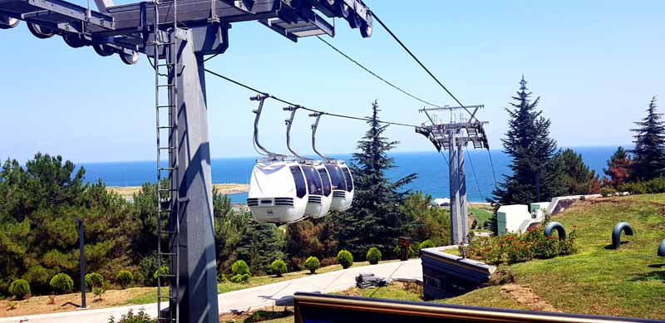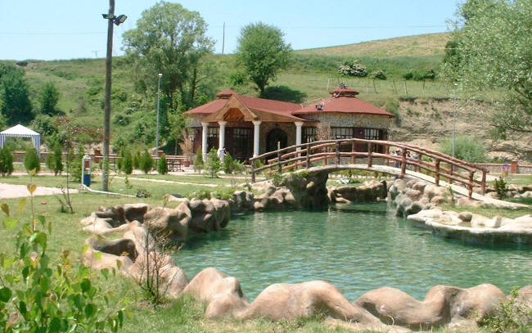
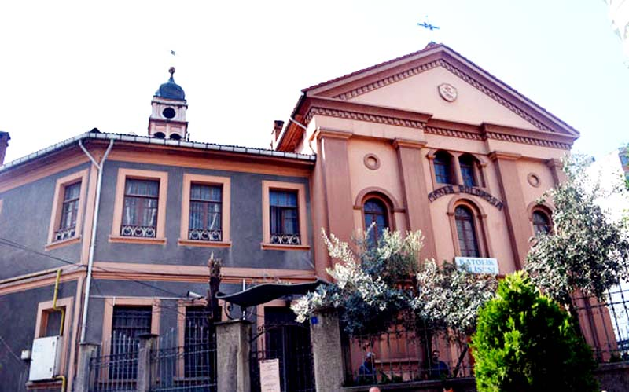

Traveling to Samsun
What is the quickest way to Samsun?
The quickest way to get from Istanbul to Samsun is to fly and takes around 1h 35m. Samsun has an airport, so you do not have to land other cities to get Samsun.

Samsun airport information
How can you reach the city?
Public Transport:
It takes 30 km journey from the airport to Samsun city center using the municipal bus service which departs from the stop just 5 minutes’ walk from the terminal building. The journey to the city center takes around 40 minutes. Or you can take a taxi, but it costs more than a bus.

Our Contacts
Facebook
E-mail - office@mozaik.org.tr

Regarding any questions, please contact us!

