
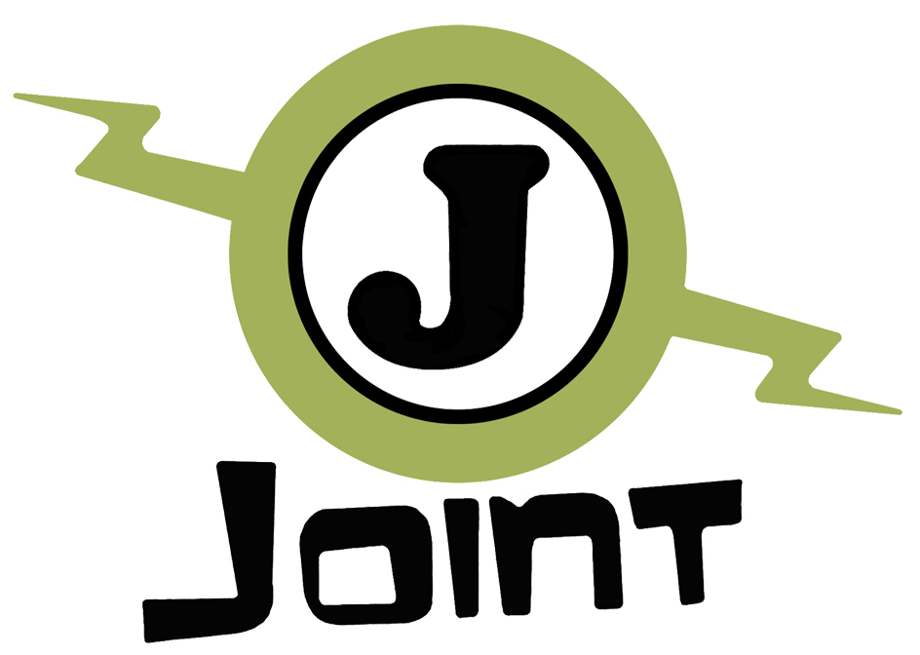

EVS Volunteer Selection

If you would like to become EVS Volunteer in Istituto Walden, in Sciacca – Sicily - we kindly ask you to fill in this survey in order to know if you are the right person for the EVS and to have a better understanding about your preferences and profile.

Personal Details
Name
Surname
Date of Birth
Address (Country, City, Street, Postal Code)
Second Address:
Nationality
Mobile N°
Email
Skype
Sending Organization name and contact (If any)

APPLICATION FORM

- Are you available for a project lasting 9 months, from the beginning of April 2019 to January 2020?

- Why are you interested in taking part in this project?

- Do you have previous experience of living abroad? If yes, how was it?

- Do you have previous experience with children? Could you please describe what did you do?

- Do you have previous experience with international/volunteering/Erasmus+ projects? Could you please describe what did you do?

- Do you speak Italian? If so, could you please describe your hobbies in Italian?

- Please give an order of importance from the most to the less important aspect during your EVS in Walden (Put N°1 for the most important aspect to N°10 for the least)
Aspects | Order of importance
Friendship
Working with children
Improving Italian
Working with disadvantaged people
Working in a team with other professionals
Learning new skills
Finding a Job
Be creative
Other …

- Which skills do you think you can bring to the project?

- What are the optional activities that would interest you the most? Why?

- How do you imagine yourself in a provincial town as Sciacca, in the south of Italy, without friends and family? How do you think to deal with it?

- Can you handle the fact that you won’t have a private space, a single room, for your privacy? Do you have experience with it?

- Please fill in the list of activities you would like to do during your spare time in order of importance, from the most important (N°1) to the least (N°14)
Activities | Order of importance
Staying on the computer
Having fun in the night
Go to concerts and cultural events
Travelling
To be a “party animal”
Doing volunteering
Reading
Doing sport
Going to the cinema, watching Tv
Going to the disco
Using social networks
Doing manual works
Cooking
Other …

- How do you imagine yourself in a job environment working with people with fewer opportunities and disables in a hierarchical setting?

- What would you like to learn during this experience?

- Do you have some plan after this EVS Project?

- Last but not the least, tell us about your skills and why we might select you ☺

Please send it back to
candidature.sve@associazionejoint.org
together with your Curriculum Vitae.
If you'll be selected for the next step of the selection we'll contact you for a Skype interview.

Thank you for your cooperation!

